Art, Design Technology and Music
In art we will use natural materials to create art both inside and outside.
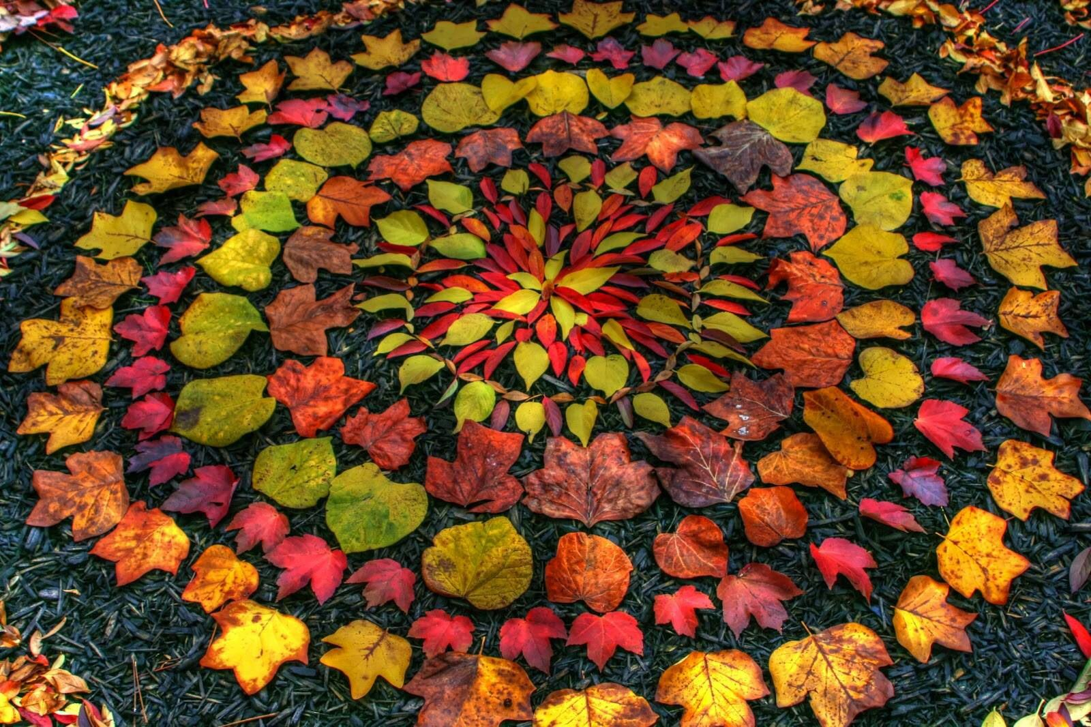

English
We will continue to read and write across a range of genre including, explanations and persuasive writing.
We will continue to work on improving Grammar, punctuation and spelling,

Sow, Grow and Farm.
PSHE
We will learn about taking responsibility for our own health and well-being; about different some types of drugs and their uses and their effects on the body particularly the liver and heart, gangs and exploitation and mental health and managing stress.


Maths
The topics we will be covering this term include: volume, area and perimeter, 2D shape and angles.
Please continue to work with your child developing speed and fluency with the multiplication tables.

We will experience ‘mass’ whilst
Understanding of the World
(History, Geography, Computing and RE)
In RE we will look at the Kingdom of God and how Christians’ beliefs affect their way of life.
In Geography our focus is on climate and topography and how these affect agriculture. We will also explore seasonality and its effects on the farming year and produce availability.
In computing we will learn simple programming.

PE
We will play cricket on a Wednesday afternoon.

Science
We will plant and grow some fruit, vegetables and flowers in the community garden. We will also learn about food chains and how population changes can affect these: reproduction of plants and the life cycles of some animals.
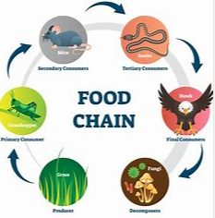

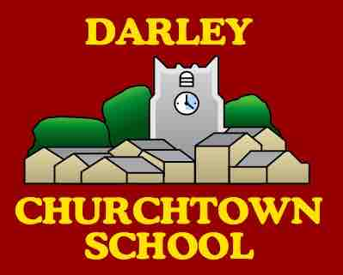
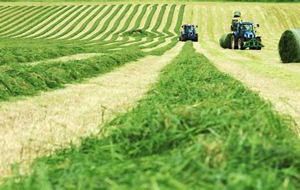
Things to remember:
The children should have their reading book in school every day. Please keep a record in your child’s homework folder when they read to you at home. It has been shown that reading for pleasure has a positive impact on learning in all areas of the curriculum so please encourage this even if it is only 15 minutes a day.

Monday | Reading book
Tuesday | Reading book
Wednesday | Reading book
Thursday | Reading book  Homework due today. Spelling test.
Friday | Reading book. Homework sent home today.

Times Tables Rock Stars
All children have a log on for Times Tables Rock Stars Times Tables Rock Stars can also be downloaded, for free, on a phone or you can access with just a browser. You do not need to download an app. https://ttrockstars.com/ Even just 5 minutes a day, will make a huge amount of difference over the year.

Class 3 Year 5 and 6
Be the best that you can be!
Summer 2022: Issue 1

