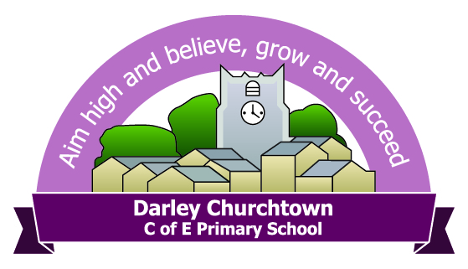
Darley Churchtown nursery registration of interest form

Child's Full Name: ____________________________________________________
Date of Birth: ____ / ____ / ______
Please circle the starting term which is relevant to your child:
A child born between: | Will be eligible for a free place from:
1st April and 31st August (inclusive) | 1st September (or from the start of the Autumn term following their 3rd Birthday).
1st September and 31st December (inclusive) | 1st January (or from the start of the Spring term following their 3rd Birthday, if spaces are available).
1st January and 31st March (inclusive) | 1st April (or the start of the summer term following their 3rd Birthday, if spaces are available).

Please fill in the exact times that you need care for your child(ren)
AM sessions:  9am - 12pm  PM sessions:  12pm – 3pm  Full day = 9am - 3pm | Funded Hours |  | Paid Hours |  | Please state if you would like your child to have a paid school lunch or you will provide lunch for them
 | Start | Finish | Start | Finish
Monday
Tuesday
Wednesday
Thursday
Friday
Parent/ carer contact details:

Name:

Email:

Phone number:

Please return to: info@darleychurchtown.derbyshire.sch.uk

